Week 4 - Assignment

Jose Herrera Medina

CST 499: Capstone for Computer Software Technology

Professor Joseph Rangitsch

October 7, 2024

# Development of Course Registration, Course Listing, and Course Deletion

This paper outlines the steps in developing the course registration, course listing, and course deletion functionalities for an online course registration system. The system is designed to allow students to register for courses, view their registered courses, and unregister from courses. The system also includes a waitlist feature to manage enrollment in incomplete courses.

The development process involved creating several PHP scripts, namely course_registration.php, course_list.php, and delete_course.php, each serving a specific purpose in the course management process.

# Course Registration (course_registration.php)

The course_registration.php script handles the registration of students for courses. The script checks if the user is logged in and retrieves the course ID from a form submission. It then checks if the course is entire by querying the database for the maximum and current enrollment for the specified course. If the course is not complete, the student is enrolled in the course. Otherwise, the student is added to the waitlist for the course.

# Course Listing (course_list.php)

The course_list.php script displays a list of all available courses and allows students to register for courses they are not already registered for. The script checks if the user is logged in and retrieves all courses from the database. It then iterates through the courses and displays each course's name, semester, and maximum enrollment. For each course, the script checks whether the user is registered or waitlisted. A registration form is displayed if the user is not registered, allowing the user to register for the course.

# Course Deletion (delete_course.php)

The delete_course.php script allows students to unregister from courses. The script checks if the user is logged in and retrieves the course ID from a form submission. It then deletes the enrollment record and user ID for the specified course.

# Adding Courses to the Course Table

Courses are added to the courses table in the database using SQL INSERT statements. Each INSERT statement specifies the course name, semester, and maximum enrollment for a new course.

# Conclusion

Developing the course registration, listing, and deletion functionalities involved creating PHP scripts to handle user interaction and database manipulation. The system allows students to register for courses, view their registered courses, and unregister from courses. The waitlist feature ensures that students can be added to a waiting list for complete courses. The system is designed to be user-friendly and efficient, providing students with a convenient way to manage their course registrations.

# Screenshots

Courses:

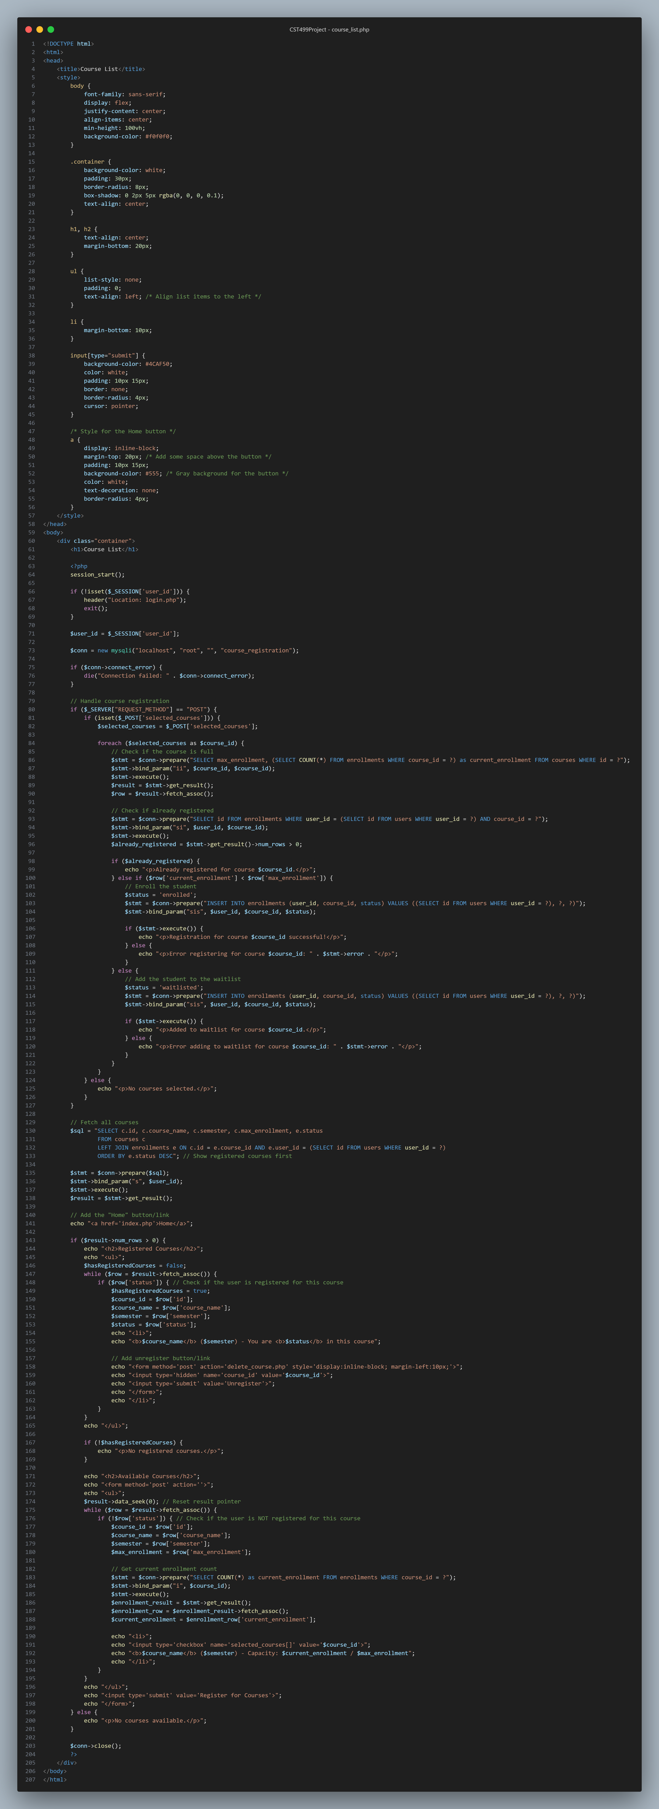

Delete Course:

Add Course:

SQL Tables:

References

Freeman, A. (2015). Head First PHP & MySQL. O'Reilly Media.

Nixon, R. (2017). Learning PHP, MySQL & JavaScript. O'Reilly Media.